

A Computer Network PBL Project Report

On

HOSPITAL NETWORK DESIGN

Submitted by

A01 – SARVESH GAWADE

A04 – IRFAN MESTRI

A05 – AKIB MANER

A11 – SANMIL GAONKAR

A33 – YOGESH KARADAGE

**Under the Guidance of**

Mr. Pradeep Khot. sir

**Department of Computer Science and Engineering**

**KIT’s College of Engineering (Autonomous), Kolhapur.**

**2021-2022**

**Acknowledgement**

We are highly grateful to the Dr Mamta.S.Kalas, HOD CSE, KIT’s College of Engineering, Kolhapur, for providing this opportunity to carry out the Mega Project Part I at the CSE department. We would like to express our gratitude to other faculty members of the IT department for providing academic input, guidance and encouragement throughout this period. We would like to express a deep sense of gratitude and thank Dr Mamta.S.Kalas and Mr. Pradeep Khot without their permission, wise counsel and able guidance, it would have not been possible to carry out our project in this manner.

Finally, we express my indebtedness to all who have directly or indirectly contributed to the successful completion of our CN PBL.

**Table of Content**

**Content Page No**

1. Introduction 3

1.1 Problem statement 3

1.2 Project purpose 3

1.3 Project scope 3

1.4 System analysis 3

1.4.1 Existing system 3

1.4.2 Limitations of existing systems 4

1.4.3 Advantages of proposed system 4

1.5 Definitions, Acronyms, Abbreviation 4

1.6 Overview 5

2. The overall descriptions 5

2.1 product perspective 5  
2.2 product function 5

2.3 user characteristics 6

3. Specific requirements 6

3.1 User interfaces 6

3.1.1 Software interfaces 6

3.2 Functional requirements 7

4. Software model 8

5. Project planning with the help of GANTT Char

INTRODUCTION

The “HOSPITAL NETWORK DESIGN” concept has existed for many years The network design is a major part of the infrastructure of a hospital. Internet speed is a major component of ensuring that healthcare providers and other professionals achieve timely access to pertinent information. The main aim of this paper is to design a hospital network which meets the requirements of a hospital network like electronic health records, on-call doctors via video communication, billing department records, keeping track of the research in progress, etc. The aim is to provide secured LAN and WLAN network. The network is designed by keeping in mind of upcoming technology in medical field. This will increase the quality of hospital service along with patient safety and clinical effectiveness

PROBLEM STATEMENT

Many Hospital networks are unreliable as there are many data breaches and network loss and the data of the users connected to the network is damaged by the 3rd party users also the patients and the doctors security against any emergency like fire.

PROJECT PURPOSE :-

To design a reliable Hospital campus Network

User friendly and easy to handle

Low cost with low maintenance

Smoke detection and fire alarm

PROJECT SCOPE

The Hierarchical is also known as the progressive inter-networking model. This model improves the construction of a structure which is dependable, versatile, and more affordable various leveled internetwork in light of the fact that instead of concentrating on packet construction, it centers around the three functional area, or layers, of your system:

SYSTEM ANALYSIS

REQUIREMENTS The proposal is to design a state of the art network for a district level hospital. The hospital consists of various departments separated among three buildings. The distance between two buildings is 50 meters. Each building has four floors. Each building has its own reception desk on the ground floor with two desktops, one central medical store and medical store room having two desktops. Each floor has three wings, and each wing has its own nurse stations containing one desktop. Apart from this there were medical instruments requiring both wired and wireless internet connectivity. Visitors of the hospitals would get limited wireless connectivity.

EXISTING SYSTEM

The existing system at visited hospital does not consist of any automation system. A single system is used in order to note the records of arrival, accommodation, etc

PROPOSED SYSTEM

The proposal is to design a state of the art network for a district level hospital. The hospital consists of various departments separated among three buildings. The distance between two buildings is 50 meters. Each building has four floors. Each building has its own reception desk on the ground floor with two desktops, one central medical store and medical store room having two desktops. Each floor has three wings, and each wing has its own nurse stations containing one desktop. Apart from this there were medical instruments requiring both wired and wireless internet connectivity. Visitors of the hospitals would get limited wireless connectivity.

ADVANTAGES OF PROPOSED SYSTEM

The primary objective of this research paper is to provide state of the art networking facilities for the IP-based medical devices, doctors, nurses, visitors and working staff of the hospital. Given below the points to throw light on the subject matter:

• Providing remote medical consultancy or to supervise the surgery/operation from remote location.

• Uninterrupted high speed internet connectivity.

• Provide better medical facilities to the patients.

• Uninterrupted communication between different departments of the hospital.

• Reducing the workload at nurse station, account department, reception desk.

• Keeping the research work of the doctors and medical records of patients secure.

• Providing limited internet access for the visitors

CONCLUSION

With the growth of Information Technology in every sector and the explosion of medical IOT devices, the design of a network of any hospital has become very essential factor. The hospitals need to have a reliable, secure and scalable network design in order to keep the patients information, doctor's research work safe, convenient communication between various departments, etc. as well as keep it ready for any new IOT medical equipment that may be introduced in the future. The hierarchical model of networking best suits our needs along with providing additional features like easy maintenance, high security, simplified troubleshooting and effective performance

EXISTING NETWORK

MODIFIED NETWORK

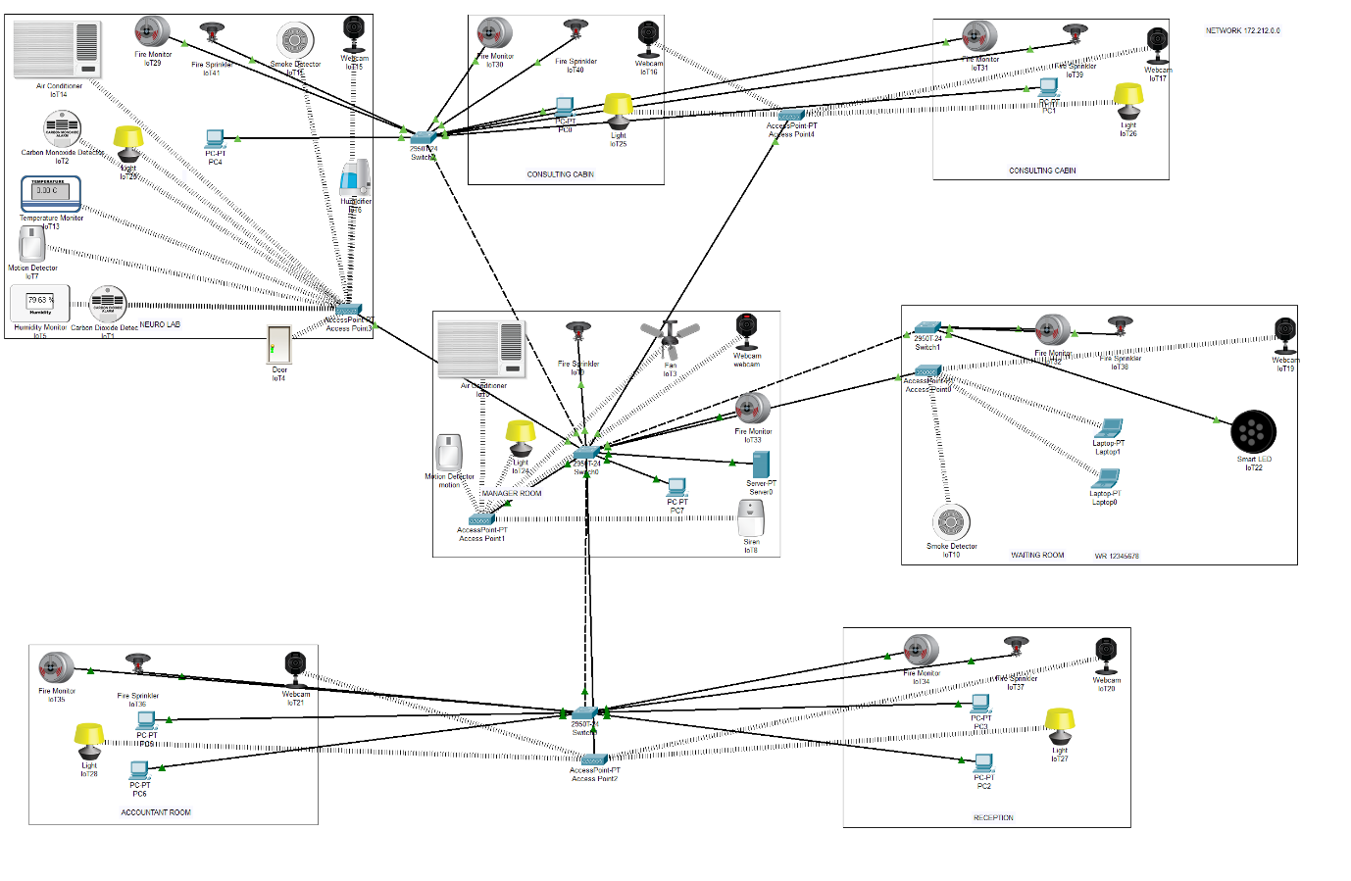

Our Team .

